Military Operations at Ellicott's Mills, MD, 1861-1865
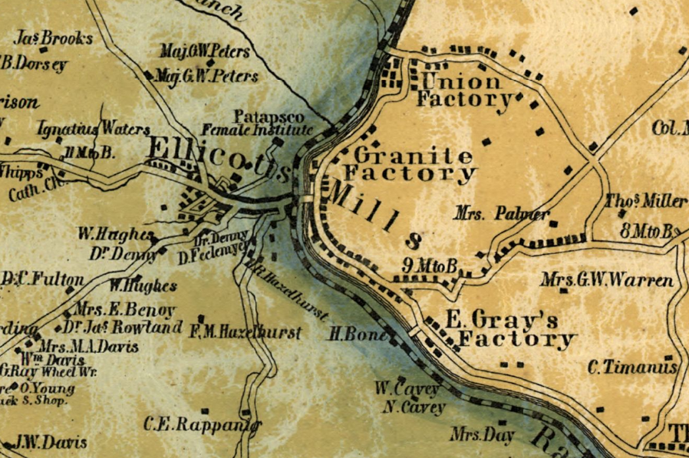Illustration 1: Martenet's Map of Howard County, Maryland : drawn entirely from actual surveys
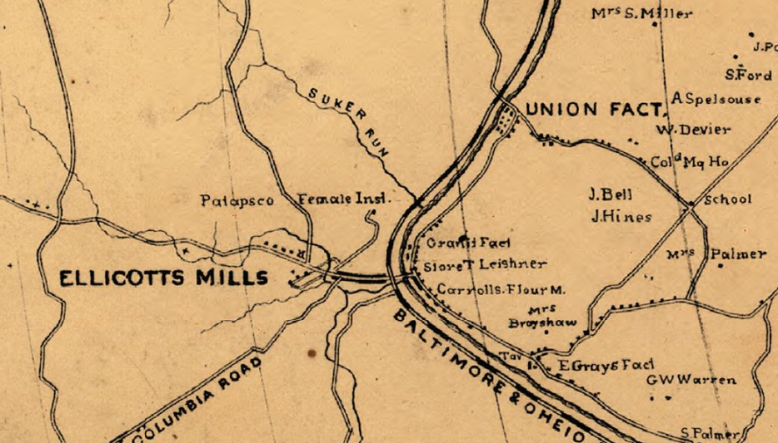Illustration 2: Military map, Baltimore Co., Md. Kaiser, George.

5/6/1861 - "DEPARTMENT OF ANNAPOLIS, May 6, 1861.

Lieutenant-General SCOTT:

GENERAL: In obedience to your command, I have occupied the station at the Relay House, nine miles from Baltimore, with the Eighth New York Regiment. I have learned however that a force of two regiments of dragoons had been raised and were in force at Ellicott's Mills, some eight miles from this point, and I therefore ordered up Major Cook's light battery, Massachusetts Volunteer Militia, which was with me at Annapolis; and as I was moving Colonel Jones' Sixth Regiment Massachusetts Volunteer Militia from the capital, I ordered them also here, so that I am here in considerable force, to wit:

Colonel Lyons, Eighth Regiment 1,000 men.
Colonel Jones, Sixth Regiment 600
Major Cook 100
Total 1,600 " - War of the Rebellion: Serial 002 Page 0623 Chapter IX. CORRESPONDENCE, ETC.-UNION.

5/13/1861 - "Across the Patapsco, and in a position to command the Baltimore and Ohio road in the direction of Ellicott's Mills, are the other two guns of the six belonging to the Boston Light Artillery. They are protected by a sort of sand battery - a superstructure of railroad sleepers, banked with sand and topped with sand bags...The New York Eighth Regiment are encamped on the west side of the Patapsco, not far from the encampment of the Sixth Massachusetts Regiment." - Evening Star, 5/13/1861

5/31/1861 - "An advance guard of sixty United States troops were at Hallafield, above Ellicott's Mills, yesterday morning." - Baltimore Sun, 5/31/1861

11/30/1861 - "On Wednesday, a soldier named Knight, belonging to Captain McGowan's company of Home Guards, at Ellicott's Mills, went over to the Patapsco bridge, and while there a gun in the hands of a member of a New York regiment, guarding the bridge, was accidentally discharged, injuring Knight so severely as to cause his death on Thursday." - Baltimore Sun, 11/30/1861

9/8/1862 - "Monday morning, September 8th, we rise early...take the Baltimore and Ohio train for Ellicott's Mills...where we unload at 3.20, march up a high hill, or young mountain, steep as a house roof, form camp, and pitch tents on the level, grassy summit..." - History of the men of Co. F, with description of the marches and battles of the 12th New Jersey Vols. ... Dedicated to "our dead."
by New Jersey Infantry. 12th regt., 1862-1865. Co. F; Haines, Wm. P. (William P.).

9/12/1862 - "September 12, 1862-2.30 p. m.
General HALLECK, General-in-Chief:
You can put any of my troops under McClellan's command. They are all on the railroad, in detachments and regiments. I have two regiments at the Relay House, one at Ellicott's Mills, one at Elysville..." - War of the Rebellion: Serial 028 Page 0275 Chapter XXXI. CORRESPONDENCE, ETC.-UNION.

9/15/1862 - "ELLICOTT'S MILLS, September 13th....The Twelfth New Jersey Regiment...is doing garrison and picket duty at this point" - The Philadelphia Enquirer, 9/15/1862

9/16/1862 - "Our regiment, Twelfth New Jersey, has been here nearly a week..Our regiment is now on detached service, some companies being on picket six miles from camp; others are guarding bridges, railroads, &c." - The Philadelphia Inquirer, 9/16/1862

12/4/1862 - "BALTIMORE, MD., December 4, 1862-10.10 p.m.

Major General H. W. HALLECK,

General-in-Chief:

I have received your dispatch. I think I can spare three regiments and a battery of six pieces-one regiment from Ellicott's Mills and two from the Northern Central Railroad. If necessary, hereafter they can be replaced by drafted militia. Let me know when you desire the troops sent.

JOHN E. WOOL,

Major-General." - War of the Rebellion: Serial 031 Page 0829 Chapter XXXIII. CORRESPONDENCE, ETC. - UNION.

12/10/1862 - "...the time has come for the regiment to leave the pleasant hills and associations of Ellicott's Mills, but not to forget the...healthful location, with that memorable spring gushing forth from the rocks, supplying the whole regiment with its clear, pure waters." - History of the men of Co. F, with description of the marches and battles of the 12th New Jersey Vols. ... Dedicated to "our dead."

["HOWARD COUNTY Ellicott City Population in 1910 1,151 Examination of the water system was made in January Ellicott City is served by a public water supply...Originally this supply was obtained from three springs and a tubular well situated on a hill northwest of the town The spring water flows to a storage reservoir ..."] - Annual Report of the State Board of Health of Maryland, For the Year Ending 1913.

6/28/1863 - "Baltimore, June 28, 1863.

(Received 7. 45 p. m.)

Honorable E. M. STANTON,

Secretary of War:

General Schenck is advised that a strong brigade of Confederate cavalry has crossed the Potomac above Washington, near Poolesville, and that it is undoubtedly making its way to the Washington Branch Railroad. General Meade telegraphs General Schenck to increase the force at Ellicott's Mills, with orders to hold that bridge, and also the Relay House, at all hazards. General Schenck has ordered a regiment of 375 men from Baltimore to the Relay, for which transportation is now waiting. The Sixth New York, from the Monocacy, will also be sent to the Relay, reaching that point about 8 this p. m. He will also send the Third Potomac Home Brigade, to protect the important bridges at Elysville. The force between the Relay and Washington is small. If such an attack as stated is to be made, increased forces should be placed at once to cover the principal bridges, viz: At Bladensburg, Laurel, and Savage. ..." - War of the Rebellion: Serial 045 Page 0382 N. C., VA., W. VA., MD., PA., ETC. Chapter XXXIX.

